**Bootloader Upload for Anet V1.0**

Uploading the bootloader with an Arduino UNO as an In-Circuit-Programmer (ISP):

1. You can burn/flash a bootloader with a Arduino UNO. The first thing is to turn your UNO into an ISP by programming it with the ISP software.
2. Download the latest version of Arduino IDE software.
3. Open Arduino IDE. Load the ISP software 'File | Examples | ArduinoISP'. Under 'Tools | Board' menu, select 'Arduino UNO'. Select the correct serial port.
4. Click on the upload button to transform your Arduino UNO into an ISP programmer. Don't worry, your UNO doesn't have to be an ISP forever; it can be reprogrammed for other purposes at any time.

Once the Arduino UNO is an ISP programmer, one can connect it to the Anet board with 4 wires:

* pin T25 MISO (Anet)on pin 12 (Arduino)

* pin T23 SCK (Anet)on pin 13 (Arduino)

* pin T33 RESET (Anet)on pin 10 (Arduino)

* pin GND (Anet)on pin GND(Arduino)

* pin T21 MOSI (Anet)on pin 11 (Arduino)

* pin V5 (Anet)on pin V5 (Arduino)

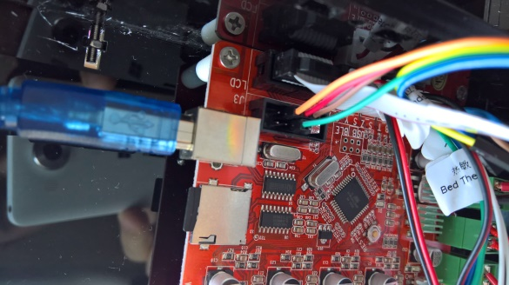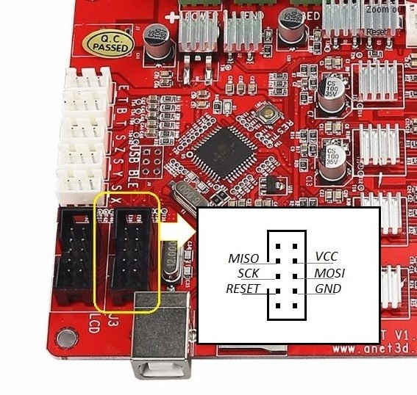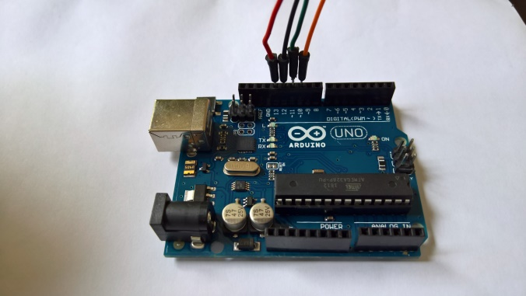

1. Connect both Arduino UNO and Anet board to your PC.(The Anet board needs power)
2. Download the latest 'Sanguino' folder and install it as described above.
3. Open Arduino IDE. Under 'Tools | Board' menu, select your card from the Sanguinos listed. If you don't know the card, you can pick one randomly. If you have selected the wrong card, the Arduino UNO will not burn the bootloader and will give you an error.
4. From the 'Tools | Serial Port' menu, select the port your Arduino UNO is on. From 'Tools | Programmer' select 'Arduino as ISP'
5. If the board you selected previously wasn't the correct board, you will receive an error message saying something like board id 'XX' isn't the right one, where XX is in hexadecimal. If 'XX' is 'ff', double check wires, otherwise try another board type under 'Tools | Board' menu or check on Google the board type with the 'XX' value.